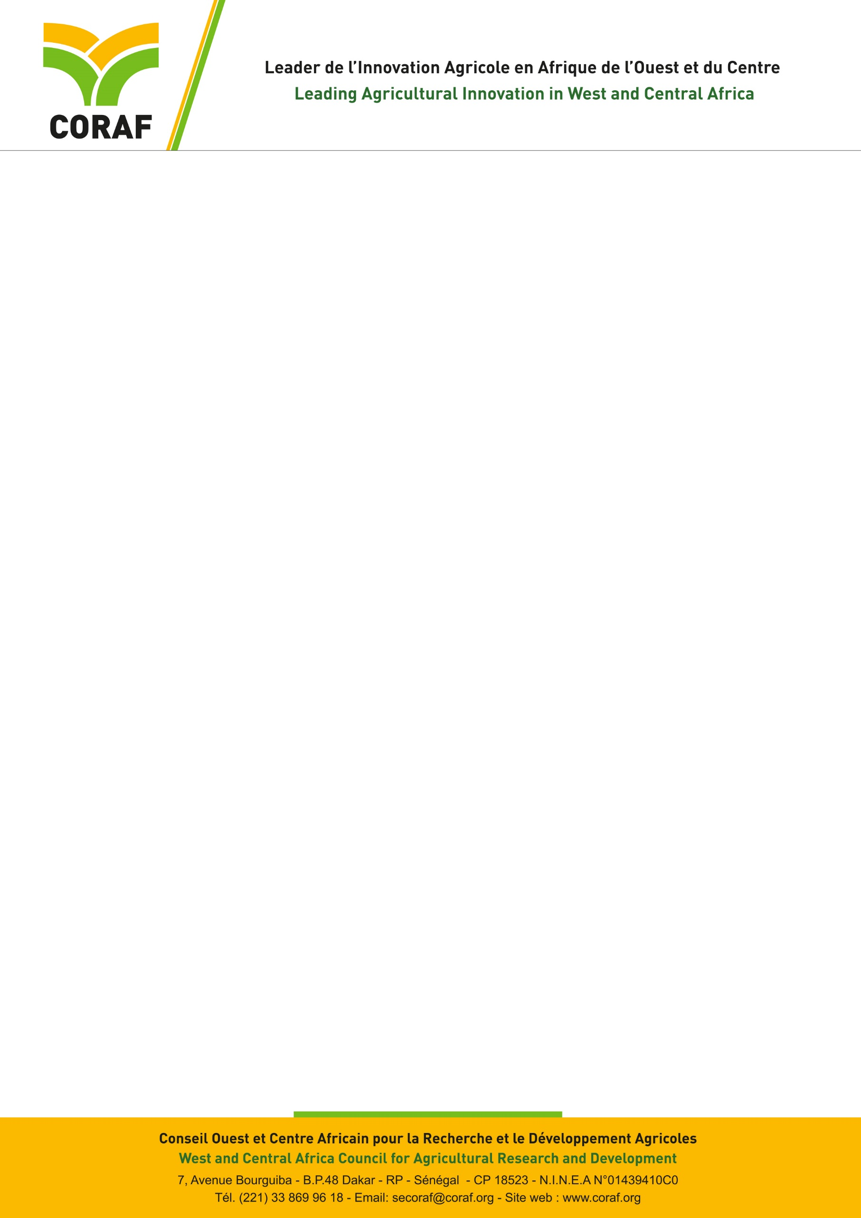

**CALL FOR APPLICATIONS**

**Job title:** Internal Auditor

**Type of contract:** Local

**Reference:** 01/AI/2025

**Location:** Dakar (Senegal)

**Opening Date:** 1st October, 2025

**Closing date:**  17 October, 2025

|  |  |
| --- | --- |
| **About CORAF and the Program** | |
| The West and Central Africa Council for Agricultural Research and Development (CORAF), founded in 1987 brings together the National Agricultural Research Systems (NARS) of 23 countries in West and Central Africa: Benin, Burkina Faso, Cameroon, Cape Verde, Central African Republic, Chad, Congo, Ivory Coast, Democratic Republic of the Congo, Gabon, Gambia, Ghana, Guinea, Guinea-Bissau, Liberia, Mali, Mauritania, Niger, Nigeria, Sao Tome and Principe, Senegal, Sierra Leone and Togo.  The vision of CORAF mentioned in its Strategic Plan 2018-2027 is a future where populations and communities in West and Central Africa will achieve food and nutrition security and be prosperous. Its mission is to achieve a sustainable improvement of agricultural productivity, competitiveness and markets in West and Central Africa.  The Food Systems Resilience Programme (FSRP/PRSA) is a regional initiative of ECOWAS, benefiting from the financial facilitation of the World Bank. The development objective of the programme is to increase preparedness for food insecurity and improve the resilience of food system actors, priority landscapes and value chains in relevant areas.  The programme has 3 components, each with two sub-components (regional and national):  Component 1: Digital advisory services for the prevention and management of agricultural and food crises managed by AGRHYMET from CILSS;  Component 2: Sustainability and adaptability of the productive base of the food system managed by CORAF;  Component 3: Integration of regional food markets and trade, managed by ECOWAS which also ensures the overall coordination of the program. | |
| **Job title** | |
| As part of the implementation of component 2, CORAF is looking for an **Internal Auditor** (M/F). | |
| **Mission** | |
| Under the authority of the Executive Director and the direct supervision of the Director of Corporate Services, the Internal Auditor has as main missions:   * review the adequacy and effectiveness of the project’s internal control systems, including the application of the Institution’s internal control procedures for sound financial, accounting and administrative management, in accordance with universally recognized accounting, financial and administrative principles; * assess whether funds have been used efficiently, economically, and exclusively for the intended purposes; * Review project accounting records, bank reconciliations, and financial statements; * train and inform staff on the internal control procedures approved by the Institution and the Board of Directors in the field of accounting, finance and administration; * prepare audit reports at least every semester, highlighting findings, risks, and recommendations; * develop and implement internal control plans for the Secretariat; * keep complete documentation on the results of internal and external audit work carried out within the Institution and at project level; ensure the wide dissemination of audit reports and the follow-up of the implementation of the recommendations of these audits; * prepare the terms of reference for external audits; * follow, if necessary participate in audits at the level of the Institution’s projects requested by its donors; * analyze and comment on the results of external audit work submitted to the Institution; * write regular reports on the progress of the implementation of the recommendations; * make recommendations to improve the efficiency of the Institution’s financial and administrative management; * suggest and introduce accounting or administrative actions in order to correct the shortcomings observed during external and internal audits; * actively participate in updating the Institution’s accounting, financial and administrative procedures manuals; * Identify the risk areas of the Mission and make recommendations to Management for their prevention and mitigation; * keep abreast of everything the Institution is doing or planning to do to help the management team better analyze and respond to possible risks; * identify, evaluate, analyze risk factors and make recommendations for prevention; * plan its work on an annual basis, or even multi-year in large part based on this continuous risk analysis; * assess the Institution’s compliance with the laws and regulations applicable to it; * assist and advise the management team and other managers, in particular project managers and administrative managers, in understanding and applying internal control and laws and regulations applicable to the Institution; * carry out the assessment of fraud risk within the Institution; * propose actions and recommendations to be implemented to cover the risk of fraud; * ensure that cases of fraud and serious breaches are documented; * conduct investigations into reported or suspected cases of fraud; * assist the organization during external audits or audits commissioned by the funders. * Monitor and document the implementation of recommendations issued by other auditors; * provide high-level services, maintain impeccable ethical and professional standards, and in particular keep abreast of developments in one’s professional field; * conduct, if necessary, a financial and accounting audit of the Institution’s partners following the memoranda of understanding signed with them; * review procurement procedures to ensure they comply with World Bank Procurement Regulations; * verify the adequacy of documentation for procurement processes and contract management; * review the maintenance of inventory records and fixed asset registers; * conduct spot checks on selected procurements and payments to assess compliance; * perform periodic physical verification of assets procured under the project; * perform any other task assigned by the hierarchy in relation to his/her function. | |
| **Deliverables**   * annual Internal Audit Plan for approval by Project Management; * semi-Annual Internal Audit Reports, including findings and recommendations; * management letters with follow-up actions; * special investigation reports, as needed; * final audit summary report at end of contract. | |
| **Profile** | |
| **Training** | * Master degree (BAC + 5) in Accounting, Finance, Auditing or any equivalent diploma |
| **Experience** | * professional experience of at least seven (07) years in internal or external audit * at least five (5) years of professional experience of internal audit or finance in donor-funded or World Bank-financed projects; * good knowledge of International Standards for the Professional Practice of Internal Auditing; * good knowledge of SYCEBNL; * familiarity with World Bank financial management and procurement procedures is an asset; * high ethical standards, independence, and objectivity; * strong analytical and communication skills. |
| **Software** | * Proficiency in Word ; * Proficiency in Excel ; * Proficiency in PowerPoint ; * Knowledge of Access is an advantage; * Proficiency in Outlook. |
| **Languages** | Good written and oral communication skills in French and English |
| **Mobility** | On the Continent |
| **Application procedures** | |
| **Application file** | It must include:   * A cover letter addressed to the Executive Director of CORAF, Dakar, Senegal. **The file must be named as follows: First name initial + surname in caps _LM. For example, SMBALLO_LM);** * A detailed resume, with the names and contacts of three mandatory references (email, address, and phone). **The CV file must be named as follows: First name initial +Surname in caps_CV_Month and year. For example, SMBALLO _CV October 2025.** |
| **Contact** | Applications should be sent to the address  [rh@coraf.org](mailto:rh@coraf.org) |
| **Deadline for submission** | 17 October at 23H59 |

**Only shortlisted candidates will be contacted for an interview**