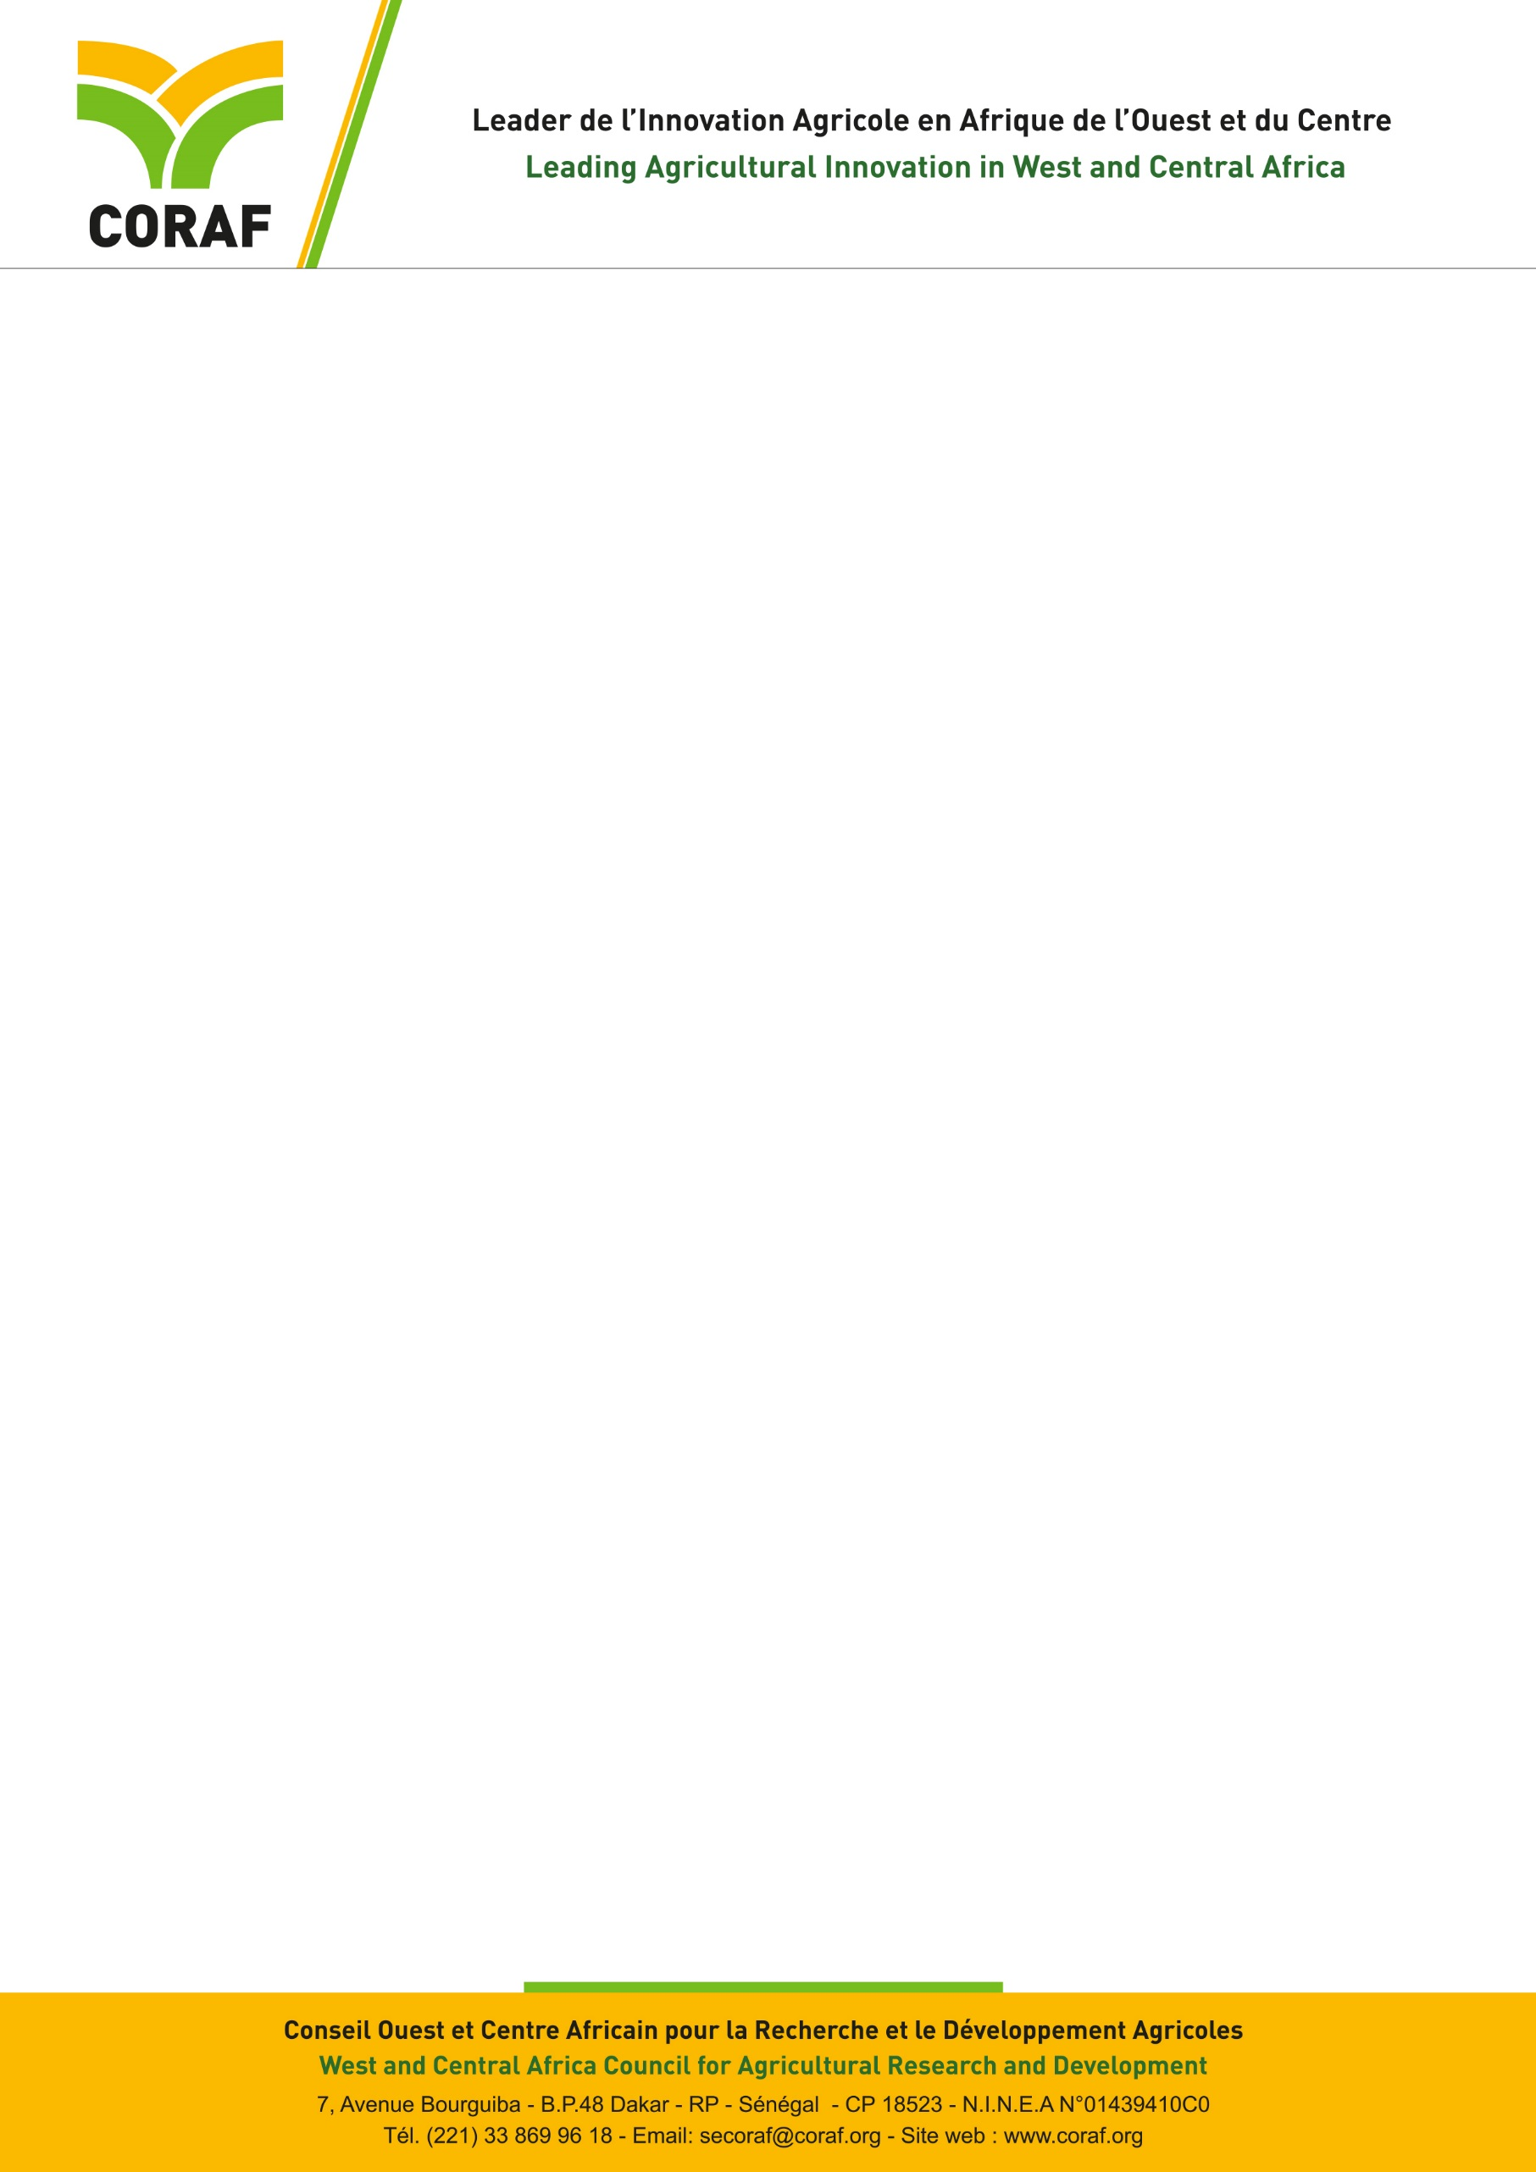

**CALL FOR APPLICATIONS**

**Job title:** Accounting Assistant

**Type of contract:** Local

**Reference:** 02/AC/2025

**Location:** Dakar (Senegal)

**Opening Date:** 1st October, 2025

**Closing date:**  17 October, 2025

|  |  |
| --- | --- |
| **About CORAF and the Program** | |
| The West and Central Africa Council for Agricultural Research and Development (CORAF), founded in 1987 brings together the National Agricultural Research Systems (NARS) of 23 countries in West and Central Africa: Benin, Burkina Faso, Cameroon, Cape Verde, Central African Republic, Chad, Congo, Ivory Coast, Democratic Republic of the Congo, Gabon, Gambia, Ghana, Guinea, Guinea-Bissau, Liberia, Mali, Mauritania, Niger, Nigeria, Sao Tome and Principe, Senegal, Sierra Leone and Togo.  The vision of CORAF mentioned in its Strategic Plan 2018-2027 is a future where populations and communities in West and Central Africa will achieve food and nutrition security and be prosperous. Its mission is to achieve a sustainable improvement of agricultural productivity, competitiveness and markets in West and Central Africa.  The Food Systems Resilience Programme (FSRP/PRSA) is a regional initiative of ECOWAS, benefiting from the financial facilitation of the World Bank. The development objective of the programme is to increase preparedness for food insecurity and improve the resilience of food system actors, priority landscapes and value chains in relevant areas.  The programme has 3 components, each with two sub-components (regional and national):  Component 1: Digital advisory services for the prevention and management of agricultural and food crises managed by AGRHYMET from CILSS;  Component 2: Sustainability and adaptability of the productive base of the food system managed by CORAF;  Component 3: Integration of regional food markets and trade, managed by ECOWAS which also ensures the overall coordination of the program. | |
| **Job title** | |
| As part of the implementation of component 2, CORAF is looking for an **Accounting Assistant** (M/F). | |
| **Mission** | |
| Under the authority of the Director of Corporate Services and the direct supervision of the Chief Accountant, the Accounting Assistant’s main tasks are to:   * Assist in recording financial transactions in the accounting system; * Maintain project accounting records, files, and documentation in an organized and secure manner; * Assist in the preparation of the financial reports of the program; * Assist in the budget monitoring; * Analyze the accounts; * Enter accounting documents; * Prepare monthly bank reconciliations; * Process payment vouchers, purchase orders, invoices, and receipts in compliance with project procedures; * Monitor the advances; * Support the end-of-year work; * Support internal and external audits missions by providing required documentation; * Contribute to the preparation of the Withdrawal applications to be submitted to the World Bank; * Ensure that all supporting documents are properly filed and referenced; * Perform any other task assigned by the hierarchy. | |
| **Profile** | |
| **Training** | * Diploma or Bachelor’s degree in Accounting, Finance or any other equivalent degree. |
| **Experience** | * Professional experience of at least three (03) years in accounting or finance. * Experience working with donor-funded projects, especially World Bank projects, is an advantage. * Good knowledge of accounting work, accounting organization and perfect mastery of the chart of accounts and accounting principles * Minimum three (3) years’ experience in a multicultural environment. |
| **Soft skills** | * Strong organizational skills and attention to detail. |
| **Software** | * Proficiency in Word ; * Proficiency in MS Excel ; * Proficiency in PowerPoint ; * Knowledge of Access is an advantage ; * Proficiency in Outlook ; * Knowledge of common Accounting software used by the World Bank financed projects. |
| **Languages** | * Good written and oral communication skills in French and English. |
| **Mobility** | * Local |
| **Other** | * Knowledge of SYCEBNL would be an asset |
| **Application procedures** | |
| **Application file** | It must include:   * A cover letter addressed to the Executive Director of CORAF, Dakar, Senegal. **The file must be named as follows: First name initial + surname in caps_LM. For example, SMBALLO_LM);** * A detailed CV, with the names and contacts of three mandatory references (email, address, and phone). **The CV file must be named as follows: First name initial +Surname in caps_CV_Month and year. For example, SMBALLO _CV October 2025.** |
| **Contact** | Applications should be sent to the address  [rh@coraf.org](mailto:rh@coraf.org) |
| **Deadline for submission** | 17 October, 2025 at 23H59 |

**Only shortlisted candidates will be contacted for an interview**